CSA1413
COMPILER DESIGN
Name: M Praneeth
Reg No: 192324184
Assignment Operators

Aim:
To write a LEX program to identify and print all assignment operators (=, +=, -=, *=, /=) used in the given C program.

Algorithm:
- Start the program.
- Include the required header file.
- Define regular expressions to identify the assignment operators.
- Read the input C program from the standard input.
- Scan the input using yylex() and identify the assignment operators.
- Print each matched assignment operator.
- Ignore all other characters.
- Stop the program.

Pseudocode:
BEGIN
Include stdio.h
Define rules for assignment operators:
+=, -=, *=, /=, =
Read the input C program using yylex()
FOR each matched operator DO
Print the assignment operator
END FOR
Ignore all other characters
END

Code:
%{
#include <stdio.h>
%}
%%
"+=" { printf("Assignment Operator: +=\n"); }
"-=" { printf("Assignment Operator: -=\n"); }
"*=" { printf("Assignment Operator: *=\n"); }
"/=" { printf("Assignment Operator: /=\n"); }
"=" { printf("Assignment Operator: =\n"); }
.|\n ;
%%
int main(void)
{
printf("Enter the C statements:\n");
yylex();
return 0;
}
int yywrap(void)
{
return 1;
}

Input:
a = 10;
b += 5;

Output:
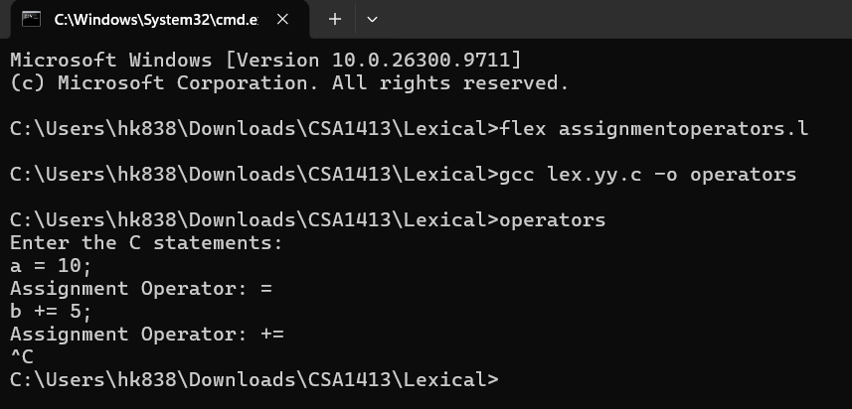

Result:
Thus, the LEX program to identify and print assignment operators in the given C program was written and executed successfully.

